Gwichin IMMERSTION APPLICATION
  - 18 month Program Details
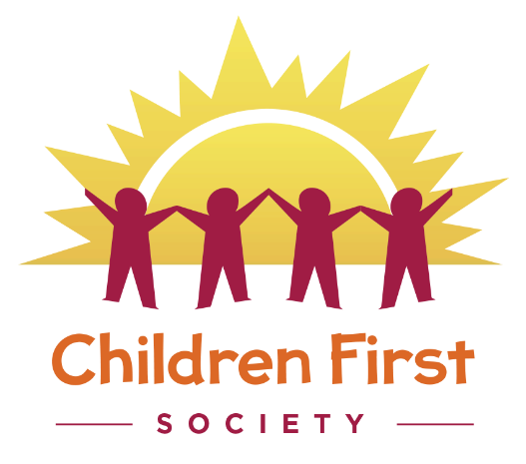

Gwich’in Tribal Council
Gwich’in land, culture & economy for a better future
Application Deadline: October 22, 2021

TAble of Contents
What is the Immersion PROGRAM? 1
Who can apply to THE PROGRAM? 1
How to Apply 1
Gwich’in Immersion Program Application 2

Gwich’in IMMERSION PROGRAM Details

What is the Immersion PROGRAM?
The Immersion program is a continued project partnership between the Gwich’in Tribal Council and Children First Society. The project is an early childhood language program where children will spend the entire day playing and learning in a purely Gwich’in environment. The program is led and run by fluent speakers with the assistance of certified early childhood staff. It will also aim to support families to learn the language and use it in their home and everyday life.
The program will use the Gwich’in language conversations, play and routines throughout the day. The elders and support staff will only speak Gwich’in. Elders will be a constant part of the program sharing their language and culture with the children, practitioners and families.
Application Deadline is October 22, 2021.
The program will run from November 1, 2021 to March 31, 2023; however, we are seeking more funding to extend the program.
There will be an orientation process October 25th -29th.
Program hours are: 8:15 am – 5:15 pm (children must be dropped off after start times and picked up before close times.)

Who can apply to THE PROGRAM?
Families who are interested in learning or enhancing Gwich’in in their home can register their children of 2 to 4 years old. Families must be dedicated to learning the language and open to taking a language course in the evening or on the weekend.
Applications must be received before the application deadline. All application deadlines and criteria must be met. Preferences will be given to children enrolled under the GCLA.

How to Apply
- Fill out the Immersion Project application form
- Write a one page letter describing why it is important to have your child in the Gwich’in Immersion program.
- Submit form and letter to Children First Society before application deadline.
- Families who are accepted will be required to fill out a full registration from for the program.

Gwich’in Immersion Program Application

Child’s Name:

Home Address:

Telephone Numbers:

E-mail Address:

Parents / Guardians: (Full names)

Parents or guardians are also required to provide a letter (no more than one page please) confirming the family’s desire to access the Gwich’in Immersion program, describing the benefits the child and family might gain from the program.
In your letter, you may wish to include information on how your family uses the traditional language, why the traditional language is important to your family, how much time/energy you are willing to put into enhancing traditional language.
Family Members in the household:
Name | Age/Adult

Print name Signature Date
For Office use Only
Date Reviewed
Approved 󠄂󠄂 Yes 󠄂 󠄂 No

