Scholarship Application
  - Program Details
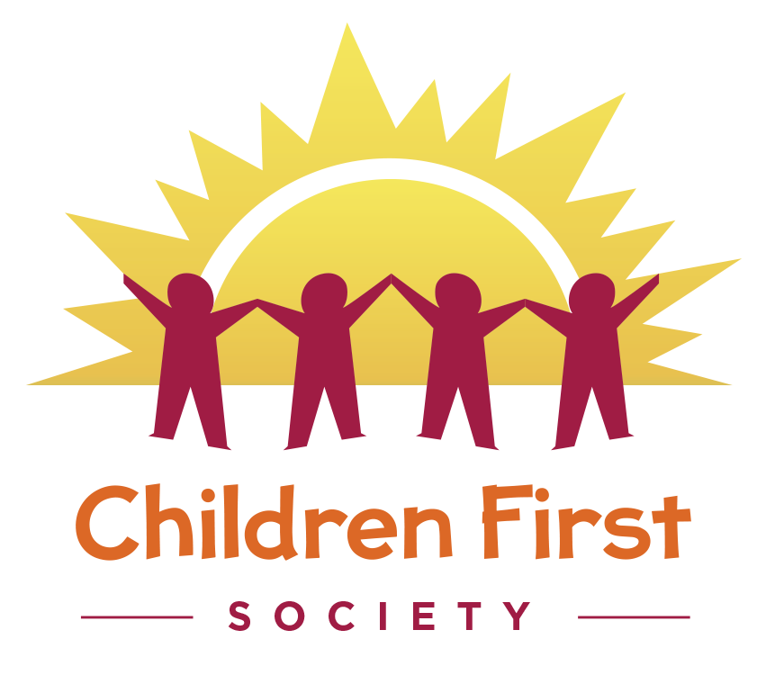
Application Deadline: April 9th, 2021

TAble of Contents
What is the Scholarship Program 1
Specific Criteria to Qualify 1
Ineligability 2
How to Apply 2
Scholarship Rates 3
Scholarship Application 4

Scholarship Program Details

What is the Scholarship Program
The Children First Scholarship program is designed to support families who would not otherwise be able to access Early Learning and Care programs for their young child. Support is short term and dependent on funding availability.
Calls for Scholarship applications will be made when funding is available.

Specific Criteria to Qualify
Specific criteria are used to check if a family qualifies for the Children First Society Scholarship Program.
Families must provide one of the following reasons for requiring child care:
- Working or self-employed
- Attending school
- Participating in an employment program
- Looking for work (only one parent or guardian)
- Living with a medical condition that interferes with your ability to care for your child
- You have been referred by a Ministry of Children and Family Development or Delegated Aboriginal Agency social worker.
If more families qualify for scholarships than the funding that is available a lottery draw of names will be made to choose the successful scholarship candidates.
A formula is used to calculate whether a family qualifies for a funding amount based on their annual income and deductions, or adjustments. This step is called income testing.
Generally speaking, families that earn up to $111,000 may qualify for funding. Families that earn more than $111,000 but have considerable deductions for family size or children who have special needs, can also apply.
Scholarships are awarded by a committee that confidentially reviews the applications and makes decisions based on criteria and need.
Applications must be received before the application deadline. All application deadlines and criteria must be met.

Ineligability
Families who are eligible for subsidy through other organizations such as the Department of Education, Culture and Employment or an aboriginal organization are not eligible for a scholarship.
You are ineligible if you have applied already in the calendar year.

How to Apply
- Fill out the Scholarship Program application form
- Make a copy of financial documents
- Submit form and copy of financial documents to Children First Society before application deadline.
- Be sure to include a brief letter why the scholarship is important to your family.

Scholarship Rates
Group child care / multi-age child care | Maximum monthly funding
Children under 24 months | $1,380
Children 24months and over but under 37 months | $1,200
Children 37 months and over but who have not reached school age | $1170
Children of school age | $720

Scholarship Application
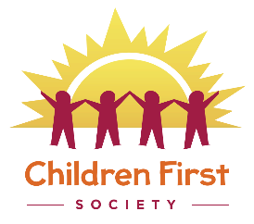
Child’s Name:

Home Address:

Telephone Numbers:

E-mail Address:

Parents / Guardians: (Full names)

Family monthly income $ ____________________please provide documentation proof (applicants may use their tax return or tax assessment for the most current year).
Parents or guardians are also required to provide a letter (no more than one page please) confirming the family’s desire to access Children First Services, describing the benefits the child might gain from the program.
In your letter, you may wish to include information on whether your child has a special reason for attending the Centre or the family has certain circumstances that would be supported by the child attending the Centre.

Family Members in the household:
Name | Age/Adult
CERTIFICATION
Applicant:
I certify that all the statements made in this form are true, complete and correct to the best of my knowledge and belief and are made in good faith.

Print name Signature Date
For Office use Only
Date Reviewed
Approved 󠄂󠄂 Yes 󠄂 󠄂 No

Employment programs are short term sessions with the goal to enhance personal employability.

